Advanced SoC Lab-fsic_sim

111061545 陳揚哲

1. Show the code that you use to program configuration address [‘h3000_5000].

There are multiple steps in every task: First, it will reset the system. Second, the system is initialized. Third, it enables the RX and TX side in system.

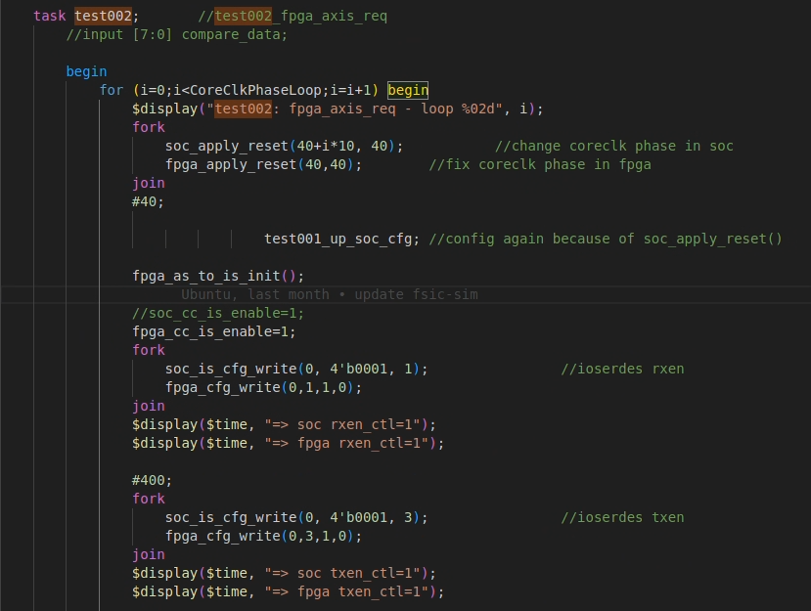

**RX**

**TX**

**initialize**

**reset**

From the step which is enable the RX and TX side in system, we can find out the how the system programs the specific address.

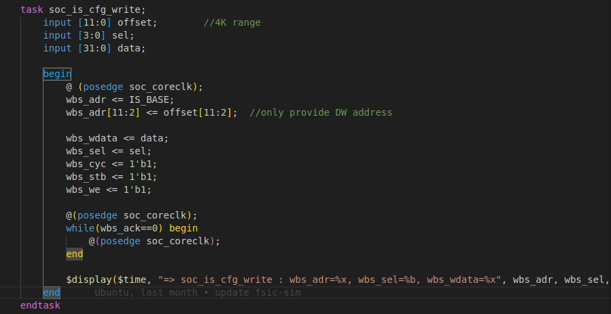

Therefore, I add new task changing the target address to [‘h3000_5000].

https://cdn.discordapp.com/attachments/896787580941639684/1221198917576818869/image.png?ex=6611b51e&is=65ff401e&hm=6961eaf02c5a33e2bf5fe55281c195d02825781b7b53a99c280b1ffd7c88bff1&=

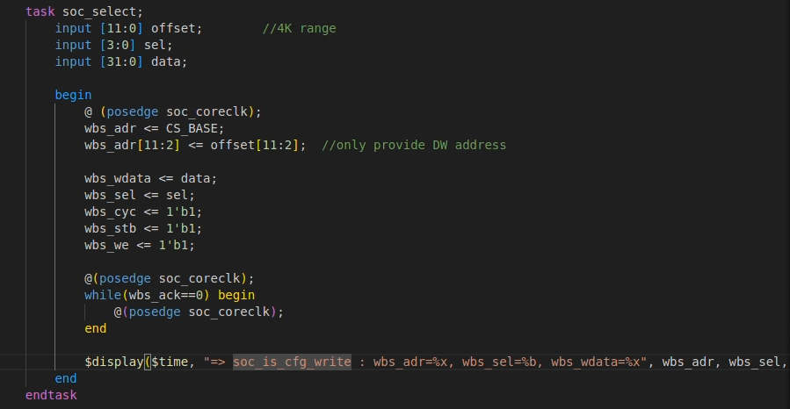

1. Explain why “By programming configuration address [‘h3000_5000], signal user_prj_sel[4:0] will change accordingly”? (Hint: trace code in config_ctrl.v)

From these code, we change the user_prj_sel[4:0] signal if

(address[11:0] == 12’h000 && axi_wstrb[0] ==1). In the case, the program data would be the user_prj_sel signal.

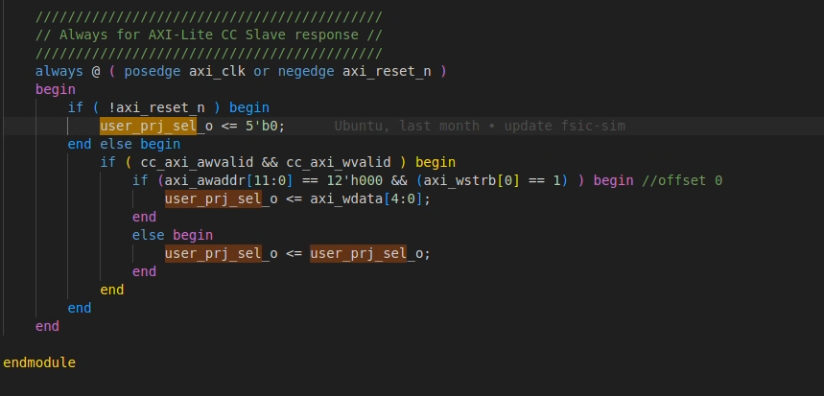

1. Briefly describe how you do FIR initialization (tap parameter, length) from SOC side (Test#1).

I use the soc_up_cfg_read and soc_up_cfg_write task to perform FIR initialization, since these tasks are programming the address base of 32’h3000_0000. First, I will check idle signal, then program the data length and taps coefficient and read back.

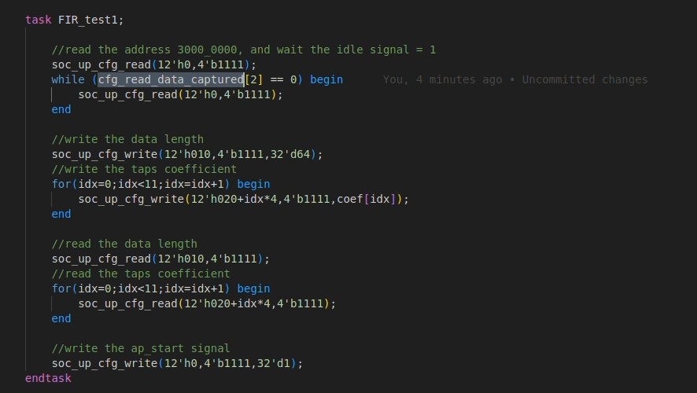

1. Briefly describe how you do FIR initialization (tap parameter, length) from FPGA side (Test#2).

Similar to test#1, I use the fpga_axilite_read_req and fpga_axilite_write_req task to perform FIR initialization, since these tasks are programming the address base of 28’h0000_0000. First, I will check idle signal, then program the data length and taps coefficient and read back.

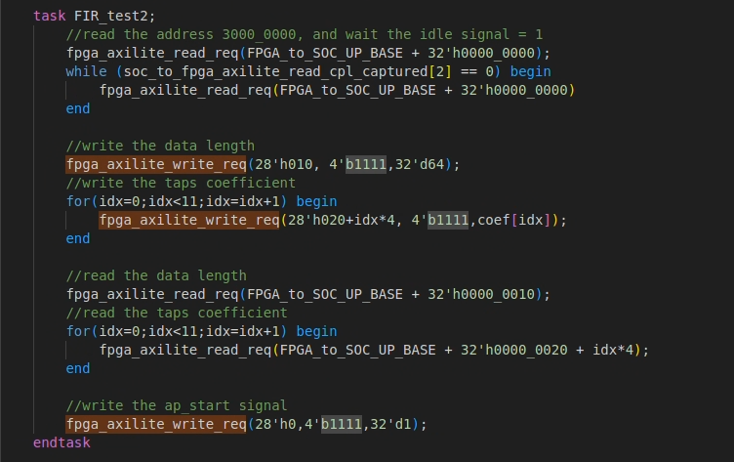

1. Briefly describe how you feed in X data from FPGA side.

In order to feed in the X data, I modify the code of test002_fpga_axis_req, which is the test of axis. I only need to change the test002_fpga_axis_req, rather than the task it used. The task fpga_axis_req will config fpga_as signal (AXIS-Switch).

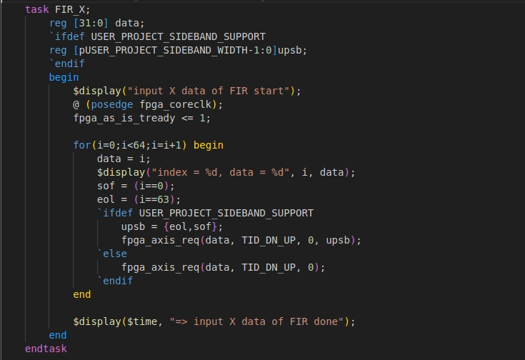

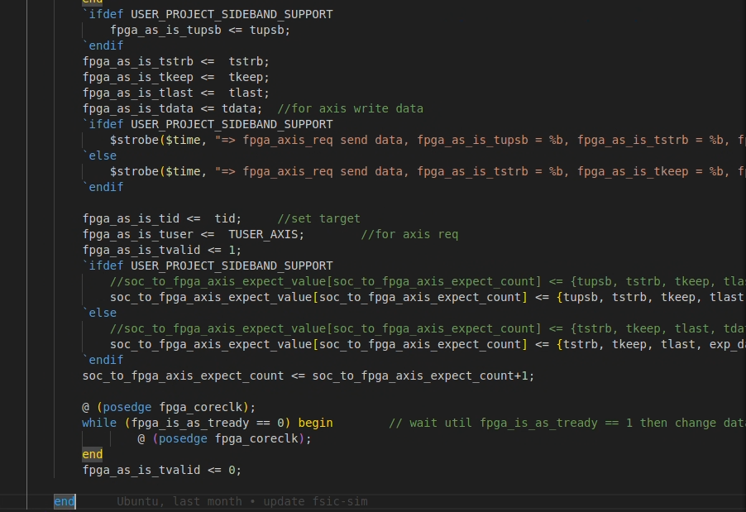

1. Briefly describe how you get output Y data in testbench, and how to do comparison with golden values.

I read back the output data Y by following code, which is the original code I didn’t do any change. These code will read out and save the output in soc_to_fpga_axis_captured[soc_to_fpga_axis_captured_count][31:0].

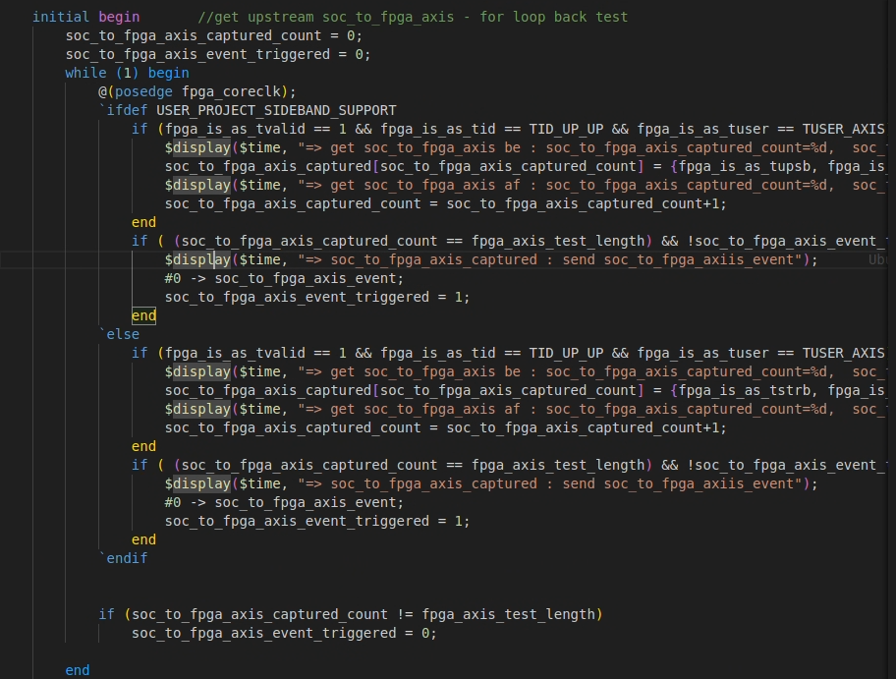

1. Screenshot simulation results printed on screen, to show that your Test#1 Test#2 complete successfully

Test#1:

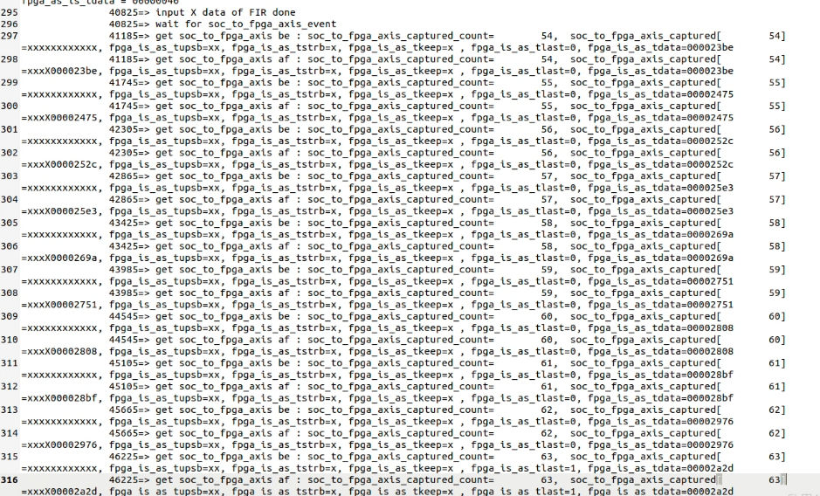

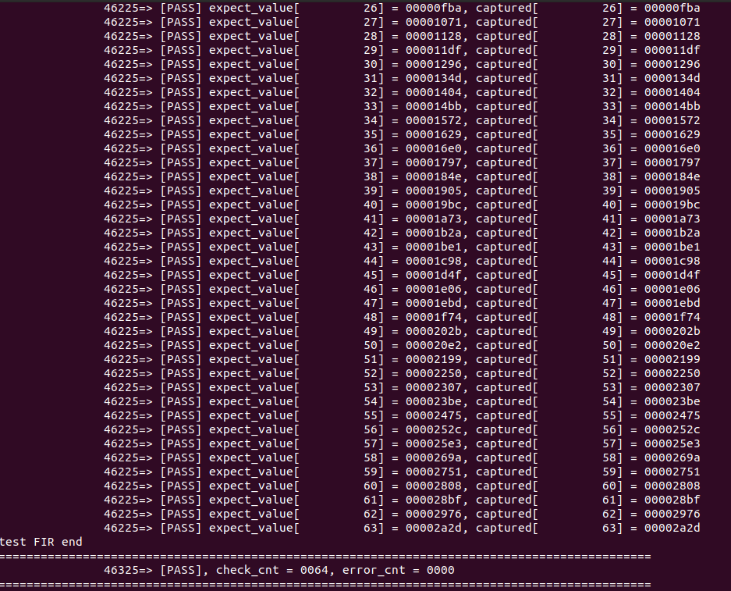

Test#2



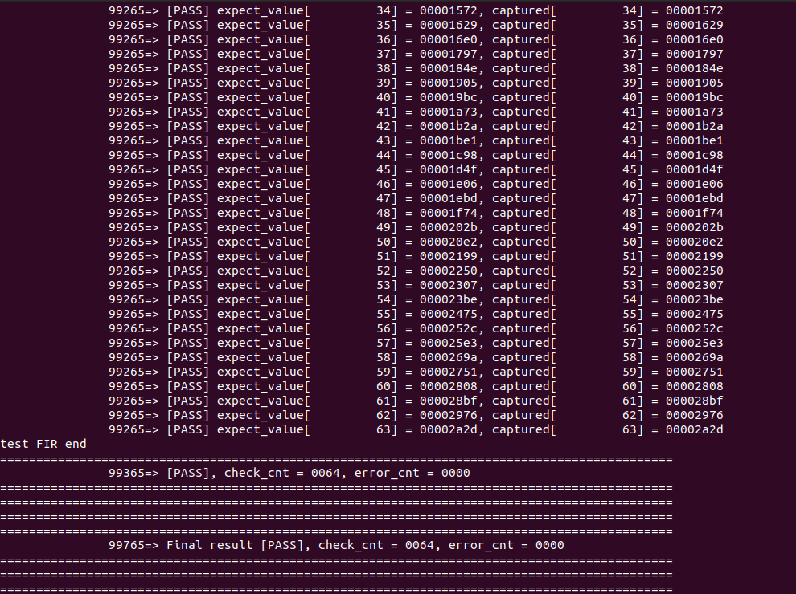

1. Screenshot simulation waveform:

* Configuration cycle (when we program [‘h3000_5000] = 32’h01, signal user_prj_sel changes accordingly)



* AXI-Lite transaction cycles (feed in tap parameters, data_length)

Write the data length and tap parameters

From SOC side:





From FPGA side:

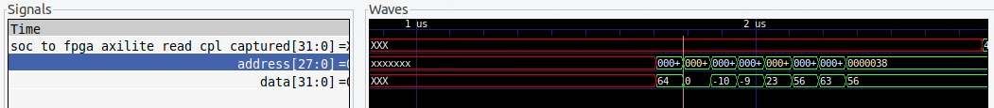

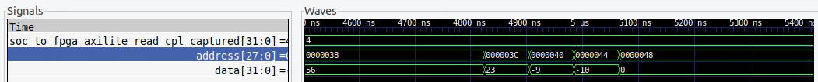

Read back the data length and tap parameters

From SOC side:



From FPGA side:



* Stream-in, Stream-out

There are several threads like the waveform below, until stream-in data reach 64.



The stream-out waveform shows the FIR will need several cycle to load new data and reset the previous output data.

